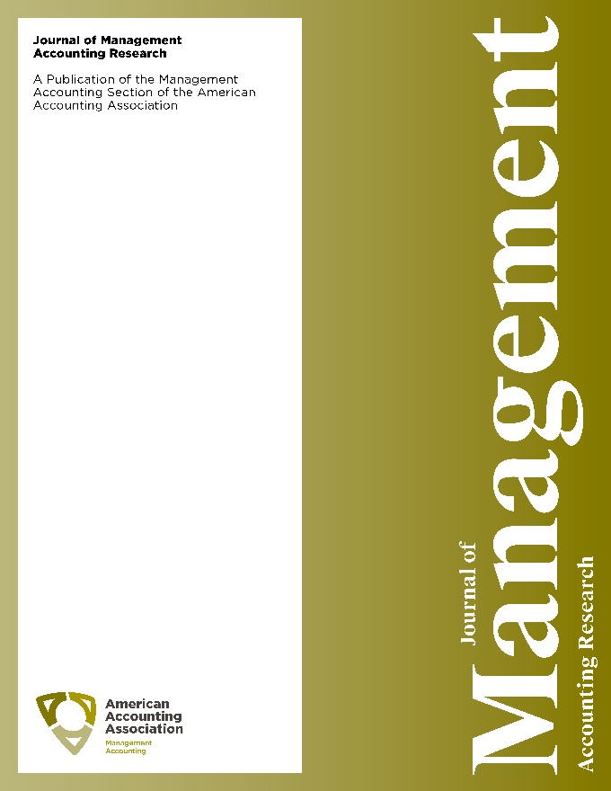

Call for Papers

Journal of Management Accounting Research (JMAR)

SPECIAL INTEREST FORUM ON
THE INTERFACE BETWEEN MANAGERIAL ACCOUNTING AND TAX

SPECIAL INTEREST FORUM

CO-EDITORS

Professor Tim Baldenius
Columbia University

email: tim.baldenius@columbia.edu

Professor Scott D. Dyreng

Duke University
email: scott.dyreng@duke.edu

MOTIVATION AND OVERVIEW
Many fundamental managerial accounting topics intersect with the corporate tax function. For example, transfer prices, which firms use for the purpose of performance evaluation, can have a dramatic effect on corporate income taxes. While some studies examine the intersection of managerial accounting and corporate income tax, the topics are most commonly researched in isolation. We believe our understanding of managerial accounting and corporate income tax issues can be significantly enhanced through concerted efforts to consider them jointly as they relate to a variety of issues.

Our objective is to attract rigorous, innovative research that extends our knowledge of the interface between managerial accounting and corporate income taxation. We are particularly interested in research that extends our understanding of existing managerial accounting practices, distortions created by existing tax laws, or that prescribes changes to the practice of managerial accounting and/or corporate taxation.

TIMELINE FOR SUBMISSIONS AND PUBLICATION:
Submissions due: August 1, 2019
Initial Decisions: October 2019
Revised Manuscripts due: March 2020
Papers advancing to the 2nd round of review for the special interest forum will receive the opportunity for a special interest forum feature presentation at the University of North Carolina’s Tax Symposium in April 2020 (conference attendance not required for acceptance in the special issue)
Final manuscripts due: September 2020
Publication: Spring 2021

RESEARCH TOPICS
Scholars from all regions of the world are invited to submit articles that examine all aspects of the intersection between managerial accounting and corporate taxation.

Topics of interest include but are not limited to the managerial accounting and tax effects and determinants of:
- Compensation arrangements, including
  - Deferred compensation
  - Share-based compensation
  - Cash-based incentive pay
  - Cash-based salary
  - Minimum wage constraints
- Transfer pricing arrangements, including
  - Trade-offs between incentive alignment, performance evaluation, and tax savings
  - Tax savings and investment distortions
- Investment decisions and capital budgets, including
  - Tax incentives such as accelerated depreciation
  - Marginal tax rates, effective tax rates, and statutory tax rates
- Contracting
  - Internal and external debt contracts
  - Employment contracts
  - Supplier contracts and tax efficient supply chain management

Other topics may include:
- Tax Avoidance, in particular its interaction with
  - Agency conflicts
  - Efficient internal information collection and processing
- Tax reform effects on internal accounting systems and managerial decisions

INFORMATION FOR AUTHORS
Manuscripts should be submitted via the JMAR portal (as a special interest forum submission) and follow the guidelines for a JMAR submission (http://jmar.allentrack.net). Manuscripts will receive an initial screening, and only those that are deemed to have a reasonable chance of acceptance in an accelerated review process will remain under consideration. Manuscripts that pass the initial screening will have a maximum of two rounds of reviews. Rejected manuscripts can be submitted as regular submissions to the Journal of Management Accounting Research if such an action is specifically recommended in the special issue rejection letter. Such a recommendation will be made when a manuscript is found to possess a strong likelihood of acceptance but is deemed to either be a poor fit with the theme of the special issue or requires revisions that are unlikely to be accomplished within the special issue’s accelerated review schedule.

Contact incoming (2019-2021) Senior Editor Eva Labro of Journal of Management Accounting Research at JMARSeniorEditor@unc.edu.
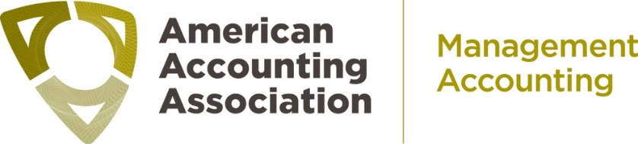
http://aaahq.org/MAS/JMAR
http://aaahq.org/Research/AAA-Journals/Section-Journal-Home-Pages/Journal-of-Management-Accounting-Research

Follow the Journal of Management Accounting Research on
Twitter @aaajmar and on Facebook at www.facebook.com/aaajmar

