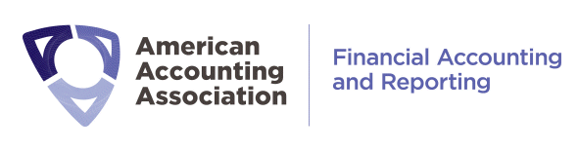

FARS Lifetime Achievement Award Nomination Form

Please limit to a maximum of 2500 words

The criteria for the award are:
- Candidates must be viewed as trailblazers, whose research has opened new areas of study and has reshaped the thinking of the academic community in a fundamental way.
- The candidates’ works that sowed the seeds for award consideration must have been published at least 20 years prior to the year in which the award will be bestowed.
- Consideration for the award will be based on the cumulative impact the candidates’ works have had and continues to have on academic thought.
Name of Nominee:

Nominee’s title and professional affiliation:

Highlights of the professional career of the nominee:

Describe the most influential works of the nominee:

Explain how the nominee meets the criteria listed in the award announcement :

List of references:
If references will be providing letters of recommendations, please limit to three letters.

Nominator’s name and professional affiliation:

Nominator’s contact information:

