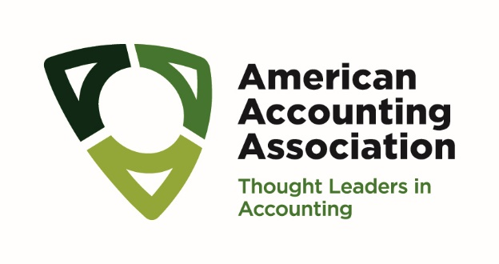

Template for 2025 AAA Outstanding Accounting Educator Award Nominations
Nomination letters should be organized by sections that correspond to the award criteria. Supplemental and supporting information addressing one or more of each criterion may be included but should appear in an Appendix.
The Nomination Packet should include the following:
- A nomination letter addressing and synthesizing the evidence supporting excellence for each of the applicable award criteria. The nomination letter must include a statement indicating that the nominee is a member of the American Accounting Association and either a fulltime faculty member or a recent retiree (within the past five years).

- Appendix 1 - Curriculum Vitae

- Appendix 2 - Letters and Other Supporting Materials organized into each of the sections of the award criteria (Successful nominees excel across multiple criteria)
- Educational Innovation
  - Letters and Other Supporting Materials
- Excellence In Teaching
  - Letters and Other Supporting Materials
- Publications Related to the Award’s Intent
  - Letters and Other Supporting Materials
- Research Guidance and Mentorship to Students (at any level - PhD, Master and Undergraduate) or colleagues
  - Letters and Other Supporting Materials
- Impactful Service to the Profession and/or Academic Community (including the candidate's department, school, or university)
  - Letters and Other Supporting Materials

