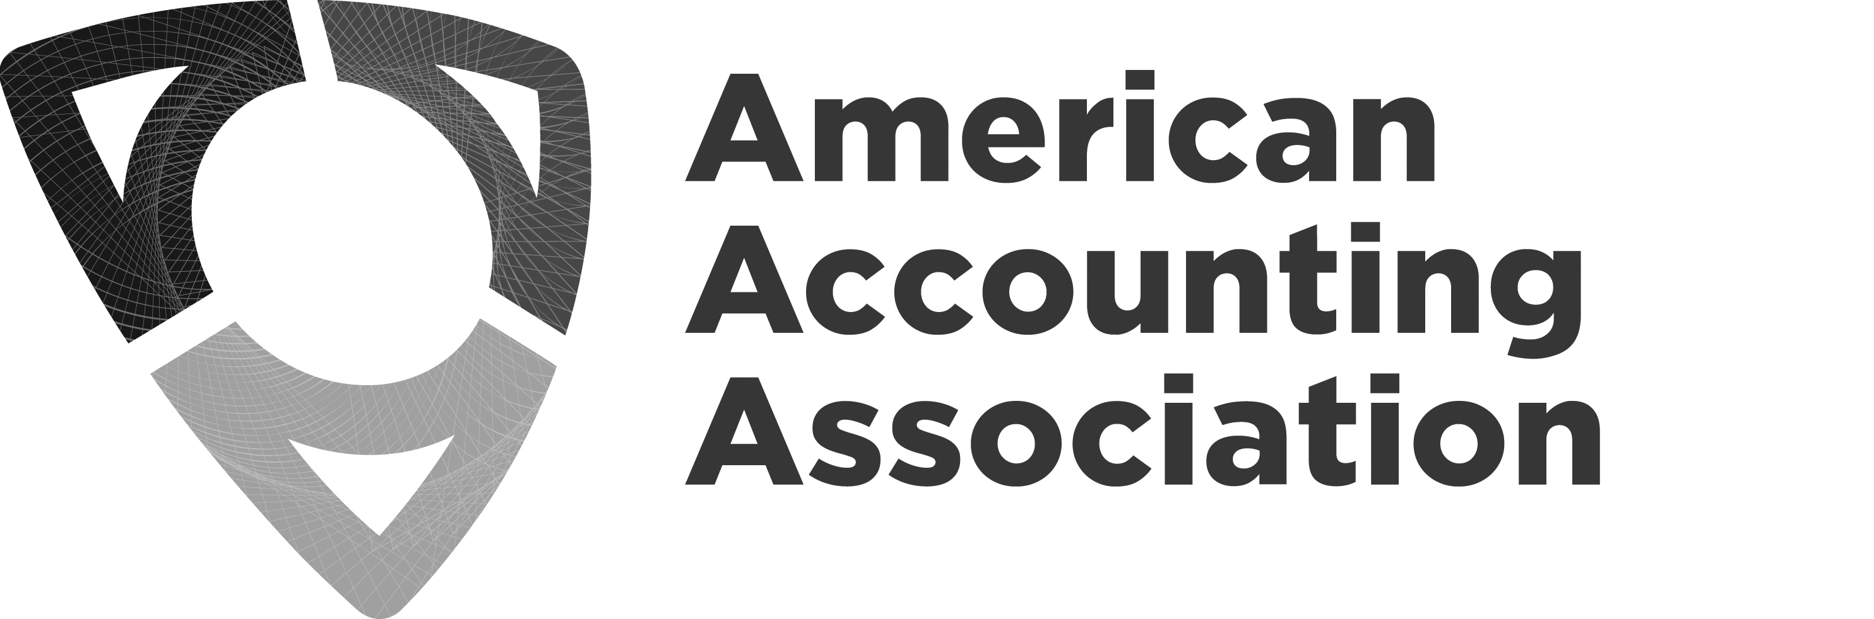
Board of Directors Meeting Agenda
Monday, June 5 – Thursday, June 8, 2023
Orlando, Florida

Board Members Attending
Mark Dawkins, President  Robert Allen, Past President  Mark Taylor, President-Elect  Anne Farrell, Vice President-Finance  Beth Kern, Vice President-Education  Norma Montague, Vice President-Diversity, Equity, and Inclusion | Ann Dzuranin, Director-Focusing on Membership  Bette Kozlowski, Director-Focusing on Academic/Practitioner  Interaction  Yvonne Hinson, Chief Executive Officer
AAA Guests & Professional Staff Attending
Randy Elder, Council Chair  Sidney Askew, Council Chair-Elect  Audrey A. Gramling, President-Elect-Elect  Margaret Christ, Vice President-Finance-Elect  Natalie T. Churyk, Vice President-Education-Elect  Linda Parsons, Director-Focusing on Membership  Cristina Florio, Director-Focusing on International-  Elect  Barbee Oakes, Consultant  Ellen Glazerman, Executive Director at Ernst & Young | Erlinda Jones, Senior Director, Meetings & Membership  Steve Matzke, Senior Director, External Relations &  Governance  Michele Morgan, Chief Financial Officer  Karen Osterheld, Senior Director, Center for Advancing  Accounting Education  Stephanie Austin, Senior Director, Publications and  Content Strategy  Mark VanZorn, Chief Information Officer  Will Campbell, Marketing and Communications Manager  Darlene Dobson, Executive Assistant- (virtual on Thursday)
Board members not in attendance
Sarah McVay, Vice President-Research and
Publications (virtual on Thursday)
Tim Rupert, Director-Focusing on Segments
Giorgio Gotti, Director-Focusing on International
Monday – June 5, 2023
New Board Member Agenda
Time | Topic (V=Vote) | Attachments  (BW – Board Website, H – Handout, L – Link) | Presenter(s)
1:30 – 1:40 pm  (10 mins) | Welcome |  | Mark Dawkins
1:40 – 2:40 pm  (60 mins) | Strategy | BW– Board Orientation Manual | Mark Dawkins  Yvonne Hinson
2:40 – 2:50 pm  (10 mins) | Break
2:50 – 3:50 pm  (60 mins) | Finance |  | Annie Farrell  Michele Morgan
3:50 – 4:50 pm  (60 mins) | DEIB |  | Norma Montague  Yvonne Hinson

Tuesday, June 6, 2023
Board Agenda

Time | Topic | Attachments  (BW – Board Website, H – Handout, L – Link) | Presenter(s)
7:30 – 8:30 am | Breakfast
8:30 – 8:40 am  (10 mins) | Welcome and agenda review for the next two days | BW – Meeting agenda | Mark Taylor
8:40 – 9:00 am  (20 mins) | CEO Update |  | Yvonne Hinson
9:00 – 10:30 am  (90 mins) | DEIB Session – “Navigating Cultural Disruption by Fostering Cross-Cultural Communication Skills” |  | Barbee Oakes
10:30 – 10:45 am  (15 mins) | Break
10:45 – 12:00 pm  (75 mins) | DEIB Session continued |  | Barbee Oakes
12:00 –1:00 pm | Lunch
1:00 – 4:15 pm  (195 mins) | Pipeline Strategy (Timing Flexible) | BW – Pipeline Strategy separate agenda | Mark Taylor  Ellen Glazerman
4:15 – 5:15 pm  (60 mins) | Voice of the AAA (Timing Flexible) |  | Will Campbell
5:15– 5:30 pm  (15 mins) | Wrap up and adjourn |  | Mark Taylor

Wednesday, June 7, 2023
Agenda

Time | Topic (V=vote) | Attachments  (BW – Board Website, H – Handout, L – Link) | Presenter(s)
7:30 – 8:30 am | Breakfast
8:30 – 10:15 am  (105 mins) | Update from 2022 Strategy Session  - Where are we now?  - Where do we still want to go?  - DEIB Update  - Publications and Research Relevance  - Membership and Meetings  - IT/Marketing  - External Relations  - Center & Education Activities | BW – May 2022 Strategy Session | All
10:15 – 10:30 am  (15 mins) | Break
10:30 – 12:00 pm  (90 mins) | Update from 2022 Strategy Session (continued)  - Breakouts |  | All
12:00 – 1:00 pm | Lunch
1:00 – 2:30 pm  (90 mins) | Membership – US & Global | BW- November membership discussion ideas | Ann Dzuranin  Yvonne Hinson  Erlinda Jones
2:30 – 2:45 pm  (15 mins) | Break
2:45 - 4:30 pm  (105 mins) | Breakouts  - Regions/Sections  - Building  - New Meetings |  | All
4:30 - 5:00 pm  (30 mins) | Wrap up and adjourn |  | Mark Taylor

Thursday, June 8, 2023
Board of Directors Meeting Agenda

Time | Topic (V=vote) | Attachments  (BW – Board Website, H-Handout, L-Link) | Presenter(s)
7:30 – 8:20 am | Breakfast
8:20 – 8:30  (10 mins) | Welcome  - Agenda review  - Approve March and April Minutes | BW -March and April 2023 minutes | Mark Dawkins
8:30 – 9:00 am  (30 mins) | Budget – Phase II (v)  - Allocation for September Pipeline Session  - New Pubs Model/Money  - Build content for Knowledge Hub  - DEIB | BW – Phase II Budget documents | Anne Farrell  Michele Morgan  Yvonne Hinson
9:00 – 9:30 am  (30 mins) | Position descriptions for upcoming Board Positions | BW – Position descriptions | Mark Dawkins
9:30 – 9:45 am  (15 mins) | Acknowledge receiving committee reports (v) | BW-AAA/AACSB/RRBM Award Committee  BW-Deloitte Foundation Wildman Medal Award Committee  BW - Distinguished Contributions to Accounting Literature Award Selection  Committee  BW - Lifetime Service Award Committee  BW -Notable and Distinguished Contributions to Accounting Literature Award Screening Committee  BW-Notable Contributions to Accounting Literature Award Selection Committee | Mark Dawkins
9:45 – 10:15 am  (30 mins) | Governance  - Committee changes for Research and Pubs Committee (criteria for serving)  - Policy on new section (v)  - Policy on endorsements/sponsorships (v)  - Change to Cook Prize Committee Charge (v)  - Ijiri Lectures | BW – Research and Pubs Committee criteria  BW– Policy on new section  BW – Policy on endorsements/sponsorships  BW – Cook Prize Committee Charge  BW- MOU for the Yuri Ijiri Lecture | Mark Dawkins  Stephanie Austin  Yvonne Hinson
10:15 – 10:30 am  (15 mins) | Break
10:30 – 11:00 am  (30 mins) | Foundation Board Members (v) | H - Handout | Mark Dawkins  Mark Taylor  Steve Matzke
11:00 – 11:15 am  (15 mins) | Request from IMA to give free membership in Tier 3 (v) |  | Yvonne Hinson
11:15 – 11:30 am  (15 mins) | Day charges for practitioner/COCPAs at AM |  | Yvonne Hinson
11:30 – 11:45 am  (15 mins) | New AAA Senior Editor Horizons (v) | BW – New Senior Editor of Horizons | Sarah McVay
11:45 - 12:00 pm  (15 mins) | Wrap Up & Adjourn |  | Mark Dawkins

