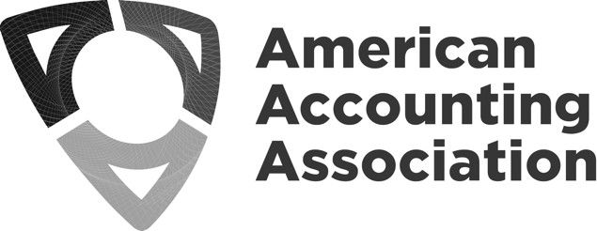
Board of Directors Meeting Minutes
Gaylord Rockies
Room- Cottonwood 2
Sunday, November 13, 2022
8:30 am -11:30 am

Board of Directors Attending
Mark Dawkins, President  Robert Allen, Past President  Mark Taylor, President-Elect  Annie Farrell, Vice President – Finance  Beth Kern, Vice President - Education  Sarah McVay, Vice President - Research and  Publications  Giorgio Gotti, Director-Focusing on International | Ann Dzuranin, Director-Focusing on Membership  Tim Rupert, Director-Focusing on Segments  Norma Montague, Director-Focusing on Diversity, Equity, and Inclusion  Yvonne Hinson, Chief Executive Officer
Board of Directors Not Attending
Bette Kozlowski, Director-Focusing on Academic/Practitioner Interaction

Guests & Staff Attending
Randy Elder, Council Chair | Erlinda Jones, Senior Director, Meetings & Membership  Barbee Oakes, Chief Diversity Officer  Karen Osterheld, Senior Director, Center for Advancing Accounting Education (virtual)  Steve Matzke, Senior Director, External Relations &  Governance (virtual)  Michele Morgan, CFO (virtual as needed)
Topic (V = Vote)
Governance – Bob Allen & Randy Elder

Bob Allen went over the nomination committee process and discussed the slate of officers for both committees. The Board was advised of the confidential Board ballot slate for this year.
- Slate of Officers from Nominations Committee
- Slate of Officers from Council Ballot Committee

Pubs Processes Task Force – Annie Farrell & Sarah McVay

Sarah asked the Board to vote to not return money for desk rejects unless the section decides otherwise. This has already been approved by the Research and Publications Committee.

MSC agrees to not return money for desk rejects unless the section decides otherwise.

Journals with no fees do not have a desk reject fee. What should be the standard desk reject fee refund for journals that do have desk reject fees and choose not to keep entire amount? Michele Morgan proposed a standard $25 desk reject fee refund. Bob Allen asked the Board to vote on this proposal:

MSC agrees to a standard $25 desk reject fee refund for any section that chooses not to keep the entire amount.
Publications – Sarah McVay

TAR Editor Slate is online and has been approved by the Publications Committee.
Some disciplines (AIS) are not well represented. Uday Murthy and David Wood were recommended to be added for AIS representation. Sarah said she understands that there are issues with missing representation, and she will request a breakdown on the underrepresented minorities from the committee. Sara said she would like to propose the current slate be approved with the condition that additional names be added after.

MSC to approve partial TAR slate with the understanding that there will be more added later.

Reflections from the Council meeting – Randy Elder & Mark Dawkins

The Council Ballot Committee did an excellent job. There were eleven nominations to review.

CEO update – there were questions about region meetings. The sooner the Meetings Committee recommends the allocation for overhead the better.

Publications costs are an important issue. The publications problem is as complex as meetings.

Pipeline work yielded good ideas and discussion around the issues. Wiley presentation got us started with the pipeline discussion. Mark will summarize and share.

The DEIB navigating cross cultural conflict workshop was great!

Membership discussions were very good, and they stayed on topic. Tracking membership in the sections is important. They discussed ways that segments working with AAA can help address the membership needs.

There was a discussion regarding combining Regions/Sections. Should we have competitions for students at regional meetings, etc. High school and college. IMA does student case competitions. Powerful recruiting tool in high schools.

Other Business

Erlinda provided AM future contract update for 2027, 2028, and 2029. The Board agreed to move forward as reported on Orlando for 2027 and Anaheim for 2028 and added some additional cities to search for 2029 to include Indianapolis, Philadelphia, Boston, NYC, Nashville.

Meeting adjourned at 10:40 am.

